GAMMA IOTA NEWS

January 2015

Dear sisters,
Happy new year. I saw from your Facebook posts that many of you got to spend time with your families. Some of you have also been traveling to exotic locales. I had some quality time with my cats, but they probably just wanted to be near me so that I could keep them warm. I have been immensely enjoying my retirement. A challenge on which I have been working is time management. I am not used to having an unscheduled day that I have to plan. I admire all of our retired members for filling their days (and nights) with worthwhile activities. I know many of you donate your time to causes which improve the lives of people, and especially, the lives and educations of children. I am going to start volunteering at my former school after winter break, helping kindergartners and first graders with literacy.
At our December meeting, we welcomed a new member, Bonnie Selk. She will be installed at our March meeting. Please keep your eyes and ears open for other prospective members. The auction was a lot of fun and successful in raising money for our scholarships. Thank you to Joanne Sawicki, Beverly Eshed, and Amy Warner for being awesome auctioneers. Once again, Bev E. donated many themed gift packets with accompanying poems. We were able to get our Little Books distributed in time for the children to take them home for winter break. We have 25 members going to the Area XI conference on February 7. You still have until January 23 to sign up. We still have spaces for our Anne Frank docent tour at the Museum of Tolerance on January 11.
In a column such as this, it is traditional for the writer to give advice or suggestions, but instead I would like to acknowledge you for your advice and suggestions to me because you are all so experienced and knowledgeable. A goal I had for my administration was to keep our meetings short by staying on focus, and I feel that I have succeeded in that. Other chapters have been inviting us to some of their activities, and I am going to start inviting them to some of ours to reciprocate the kindness, and also, to increase our numbers at events when we need to have a certain number of people.
I look forward to hearing about your trips and activities and seeing as many of you as possible at our events and meetings for the rest of the year.
Rhonda Byer, President

Coming up:
Sunday, January 11, 2:00 p.m.
Anne Frank exhibit, Museum of Tolerance

Saturday, February 7, 8:30 a.m.
Area XI conference at Doubletree Hotel, Culver City

President’s Message

Los Angeles Conservancy Art Deco Tour, November 22
From the Los Angeles Conservancy website:
Officially debuted at the 1925 L'Exposition Internationale des Artes Decoratifs et Industriels Moderne in Paris, the style now known as Art Deco took the western world by storm.
New, modern, and angular, the style was perfect for the machine age, and was used for everything from jewelry to teapots to skyscrapers. Typified by vertical lines, geometric patterns, and references to Gothic, pre-Columbian, and Egyptian art, Art Deco is stunning in its varieties of color and design.
Downtown Los Angeles boasts an extraordinary collection of Art Deco buildings, due to a building boom during the heyday of this architectural style.

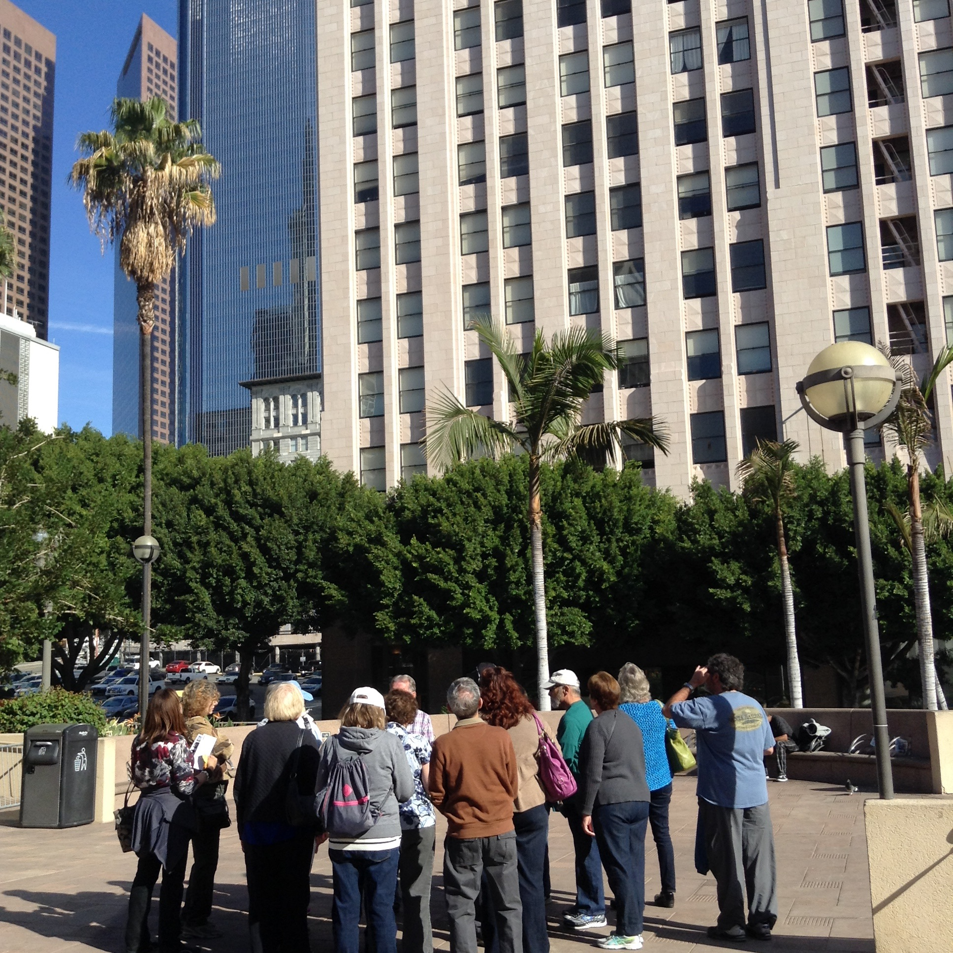

Members and guests enjoyed another fascinating tour by Los Angeles Conservancy. Our knowledgeable docent explained what Art Deco is and is not, and showed us a wide variety of buildings including several interiors not normally open to the public. Thanks to Stephanie Wexler for arranging the tour.

Chapter Will Focus on the Seven Purposes of DKG
By Eileen Miller Krause, First Vice President, Programs
“While a delightful part of our Society is found in our social gatherings, how many of our members keep in mind that we are organized for certain serious and worthy professional purposes? It follows the newer order of organizations, namely, that a body formed for specific undertakings, namely a professional association of women educators to support the professionalism and professional women educators.” --ANNIE WEBB BLANTON, founder of Delta Kappa Gamma.

With this in mind I wanted to create a vision for the future of GAMMA IOTA chapter of Delta Kappa Gamma Society International. How could we increase our membership and keep our active members active? A reorientation came to mind. A copy of our purposes was distributed to the group. So, now, for these next two years, at every business meeting, a member will present a ten-minute interactive presentation that reintroduces one of our Delta Kappa Gamma purposes. It’s both fun and educational.

The rewards of membership bear a direct relationship to each individual’s commitment. Our MISSION STATEMENT is clear… THE DELTA KAPPA GAMMA SOCIETY INTERNATIONAL PROMOTES PROFESSIONAL AND PERSONAL GROWTH OF WOMEN EDUCATORS AND EXCELLENCE IN EDUCATION.

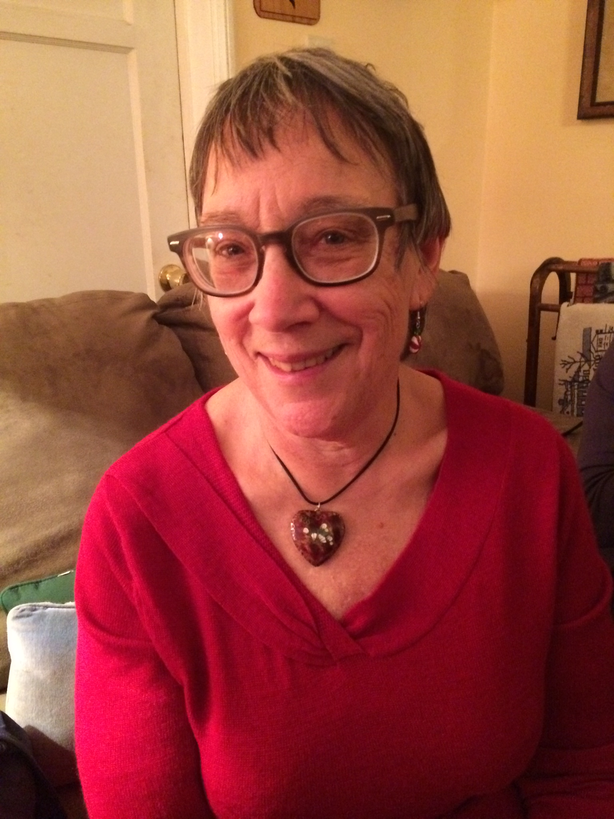
Meet Our New Chapter Member, Bonnie Selk
Biography submitted by Caryl Rainey

Bonnie Selk was invited to become a member of Gamma Iota chapter at the December meeting. She was sponsored by Marla Osband, Bev Goldman, and Caryl Rainey.
Bonnie received a Bachelor of Science degree in Speech Pathology from the University of Wisconsin’s School of Education. Then she did graduate deaf education work at USC, which included a K-12 teaching credential. She has a Masters’ degree in Jewish Education, which included administrative credential classes.
She began teaching in 1966 in California at the John Tracy Clinic in Los Angeles. She taught preschool/kindergarten classes at Oral Education Center from 1970-1985 and at times specialized in speech therapy for the deaf and hard of hearing. From 1987-91 she taught special needs children, including ESL students, at Pressman Academy. From 1991-2008 she taught first grade general & Jewish studies at Pressman Academy. She retired in 2008. She is a wonderful storyteller!!
Please join us in welcoming Bonnie to our chapter.

Gamma Iota News
January 2015
Published by Gamma Iota Chapter,
Area XI, Chi State,
The Delta Kappa Gamma Society International
Editor: Sara Fields sarafields@sbcglobal.net

